30.29: a) 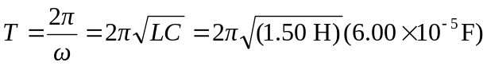
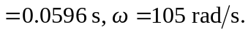
b)
c) 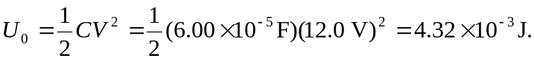
d)
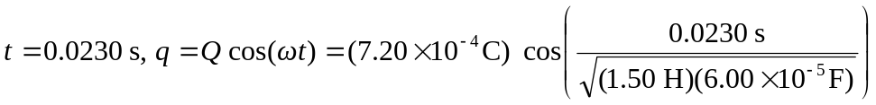
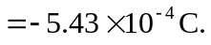Signs on plates are opposite to those at 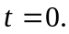
e) 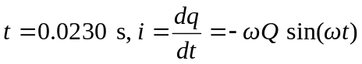
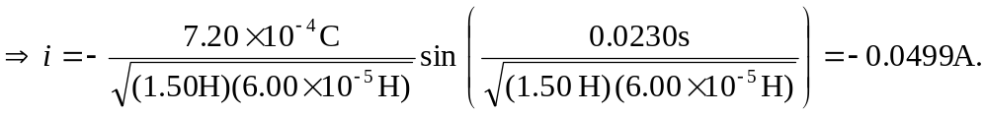

Positive charge flowing away from plate which had positive charge at
f) Capacitor: 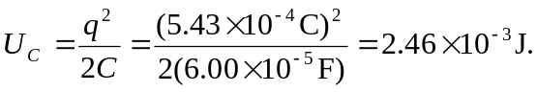
Inductor: 